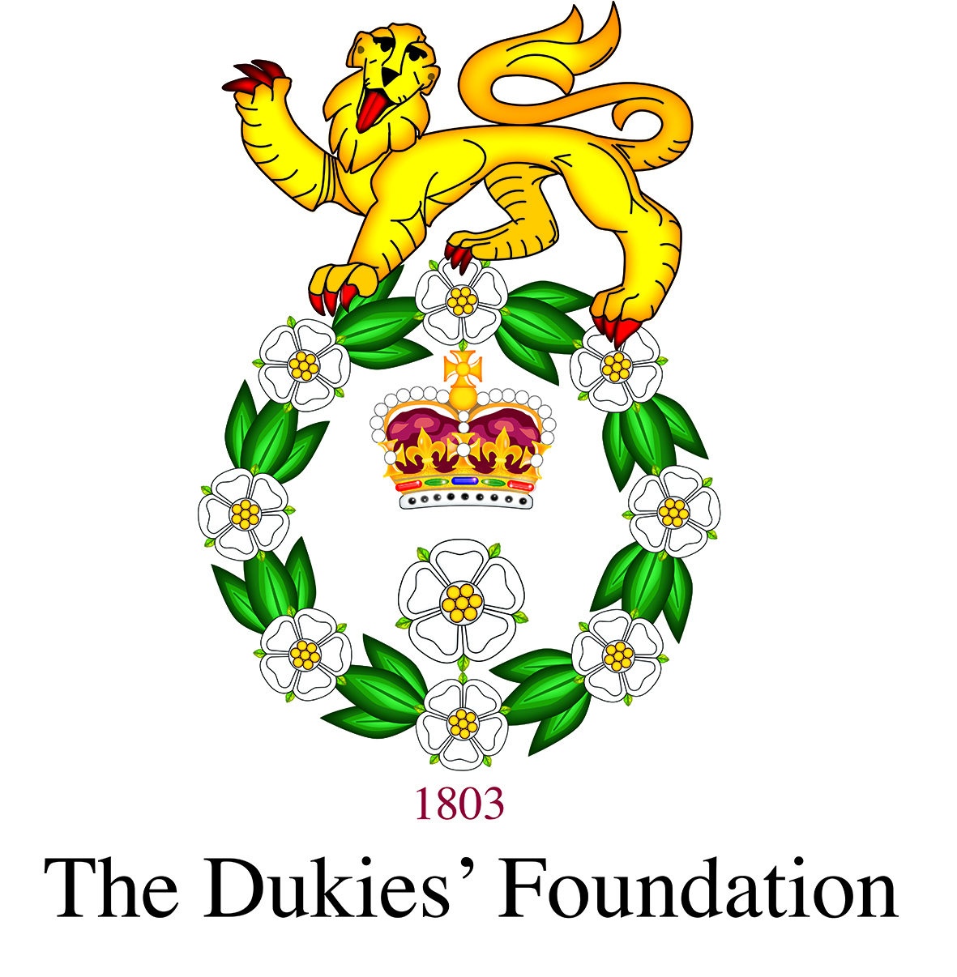m The Dukies’ Foundation - Charity No 1128684
Gift Aid Form

Title __________________________ First name* ______________________________________________________ Surname* ______________________________________________________________
Full home address*

________________________________________________________________________________________________________________________________________________________________________________
Postcode*_________________________________ Email* _____________________________________________Phone
* Required fields, if you do not own an email address please ensure you complete the phone number section.

I would like to allocate my gift towards:

☐ Student Support | ☐ Leadership Activities | ☐ The DOYRMS’ Greatest Need
☐ Other (please specify):

Regular Gift
☐ I would like to make a regular gift of: | ☐ I am currently making a regular gift and would like to change the amount to:
☐ £10 ☐ £25 ☐ £50 ☐ £100 ☐ £250 ☐ £500 ☐ £1,000 ☐ Other £20.00
Starting on 1st of month: ________________________ year: _________________ Monthly (please delete as appropriate.)
Please make start date at least one month from today.

Single Gift
☐ I wish to make a one-off gift to The Dukies’ Foundation of:
☐ £25 ☐ £50 ☐ £100 ☐ £250 ☐ £500 ☐ £1,000 ☐ Other (please specify amount), £____________________________

☐ I enclose a cheque/Charities Aid Foundation cheque payable to ‘The Dukies’ Foundation’
☐ I will make a BACS Transfer to the following account details

The Dukies’ Foundation Lloyds Bank account number: 01780588 Sort Code: 30-93-34

Legacies
☐ Please send me information about leaving a Legacy to The Dukies’ Foundation | ☐ I am leaving a Legacy to The Dukies’ Foundation

Gift Aid
If you are a UK taxpayer and choose to donate using Gift Aid, we can reclaim 25p for every £1 that you give, at no extra cost to you. To be eligible for Gift Aid, you must be a UK taxpayer and you must not pay less Income/or Capital Gains Tax in a given year than the amount of Gift Aid claimed on all your donations in that tax year. If you pay less than this amount of tax, it is your responsibility to pay any difference. Please notify The Dukies’ Foundation if you change your name/address or no longer pay a sufficient amount of tax. |  | 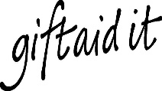
I wish The Dukies’ Foundation to treat this gift, all donations made 4 years before the date of declaration, and all future donations after the date of declaration until further notice, as Gift Aid.
Signature(S): ________________________________________________________________________________________________ ______ Date:

Please complete and return to,
Alumni & Development Officer, Duke of York’s Royal Military School, Dover, Kent, CT15 5EQ or alumni@doyrms.com
We take care of your data: All data is held securely and confidentially. See doyrms.com/Policies for our privacy policy

